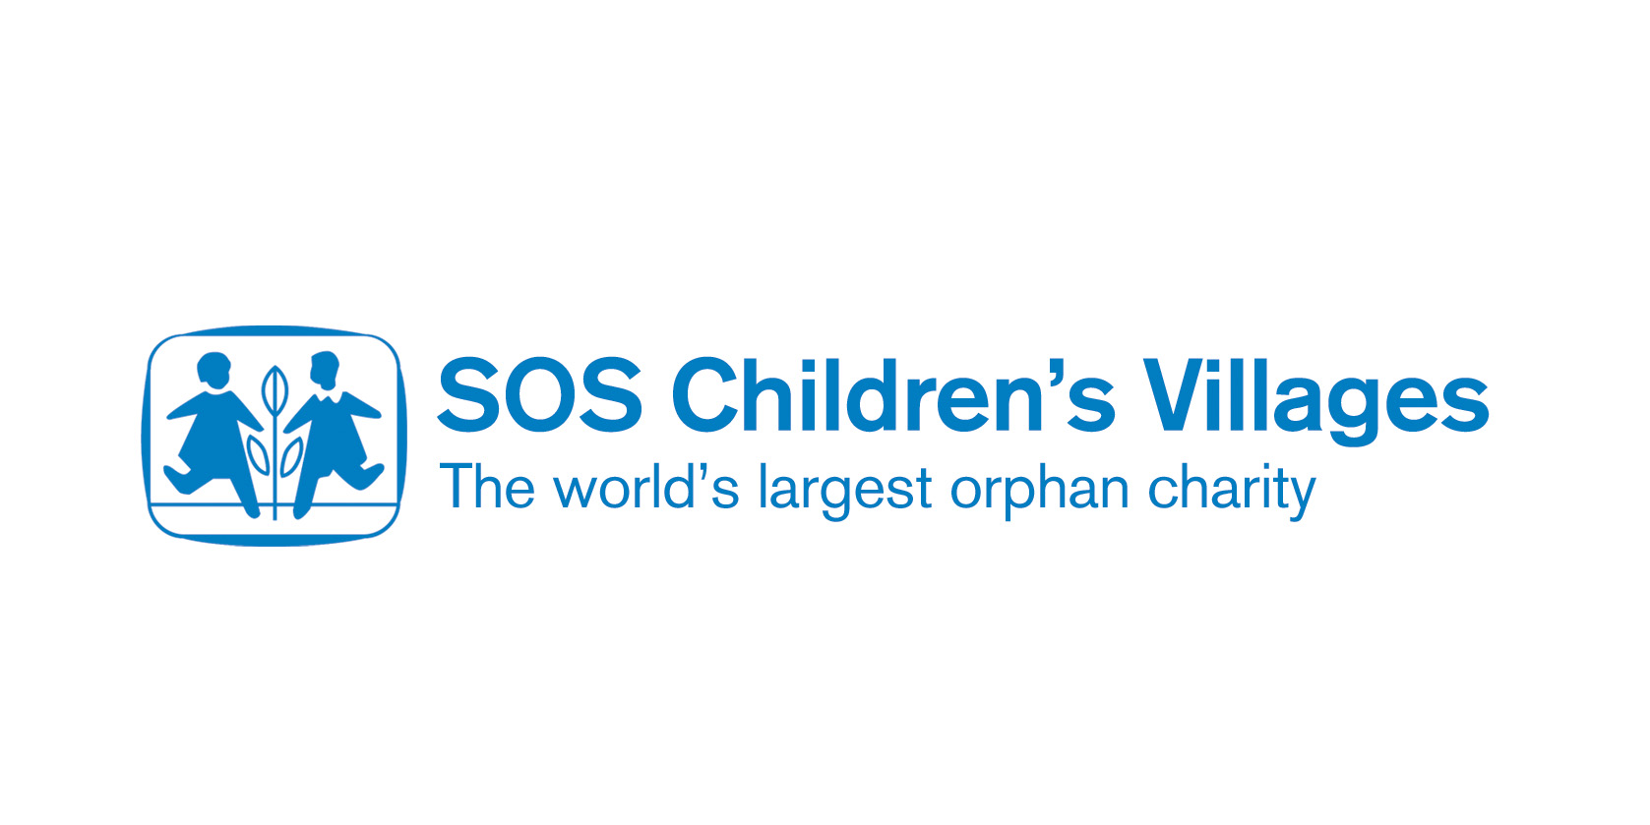

The benefits of education for children and society

Education breaks the vicious poverty cycle. If a parent is uneducated, for example, they are more likely to be unemployed or have a very low-paid job. In many parts of Africa, parents must pay school fees, and buy uniforms and stationery. As a result, parents cannot afford to send their children to school, and the cycle continues. The children, like their parents, will be confined to a difficult life: they will have little money and food, no voice in society, and are likely to be unhealthy as they are unaware of hygiene issues and cannot afford medicines. For women, the lack of an education and job prospects may mean they are forced to marry just to stay alive.
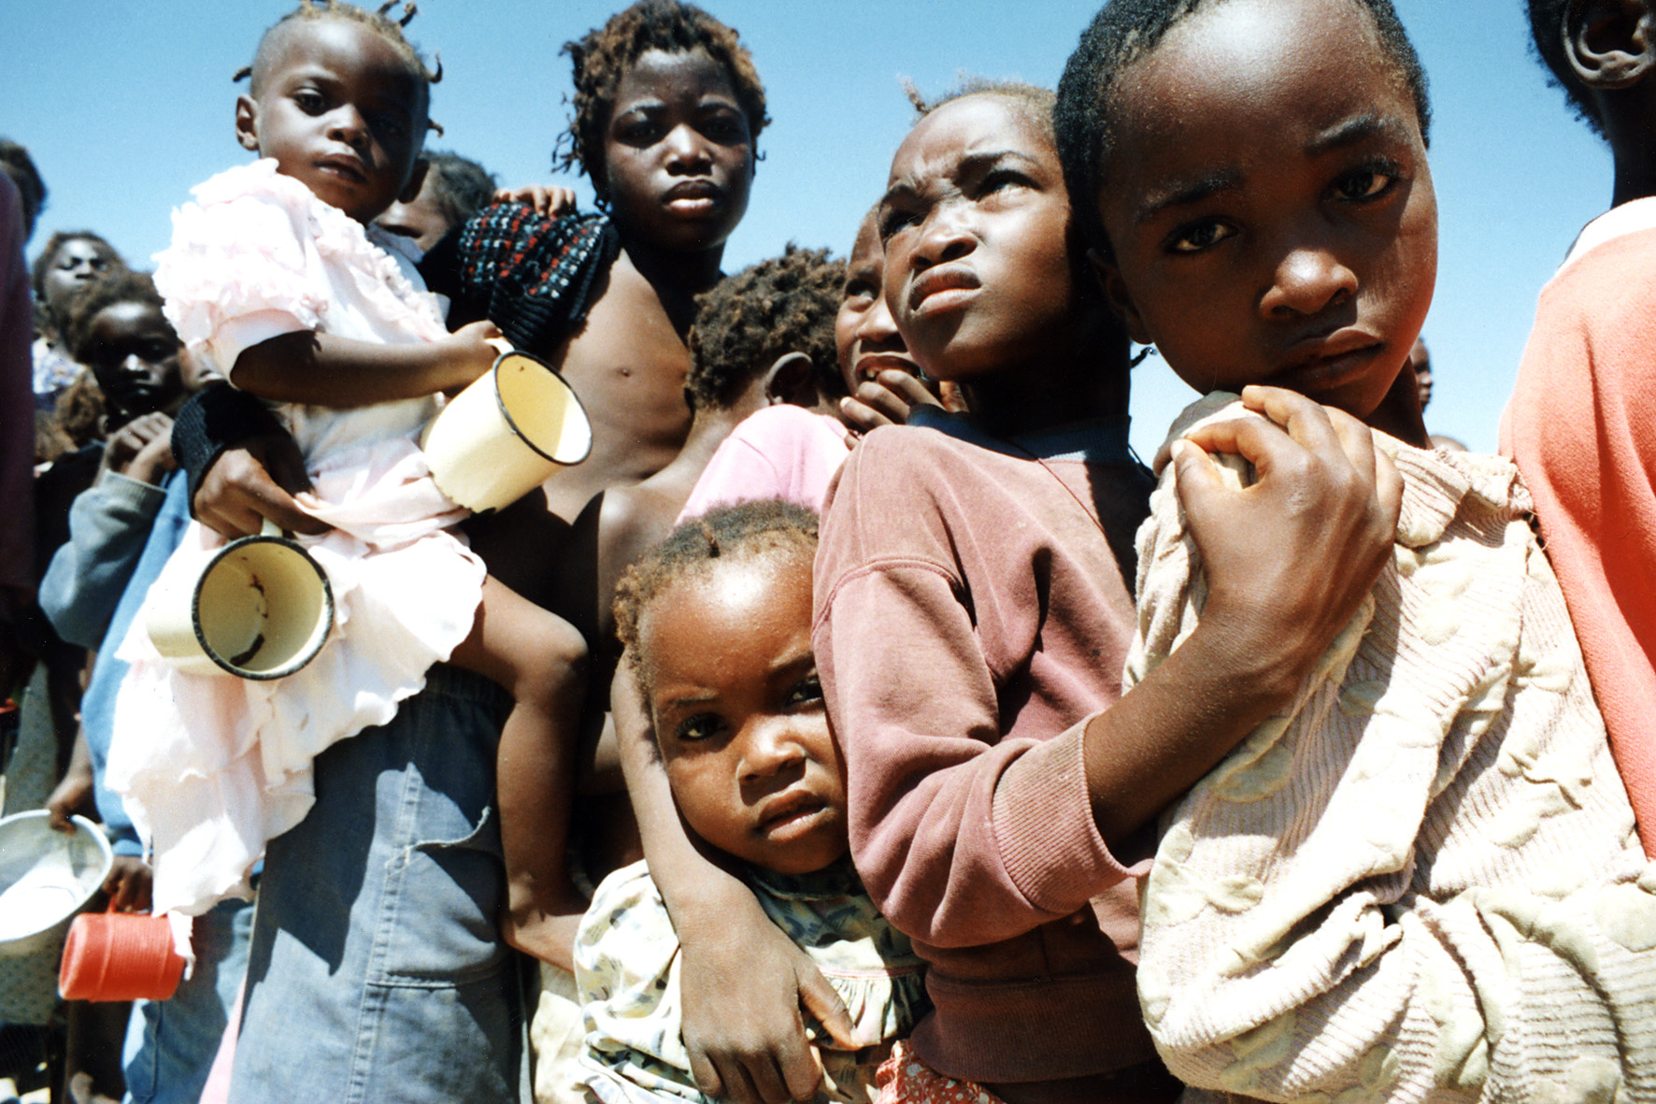

Educating a child means that a child is more likely to:

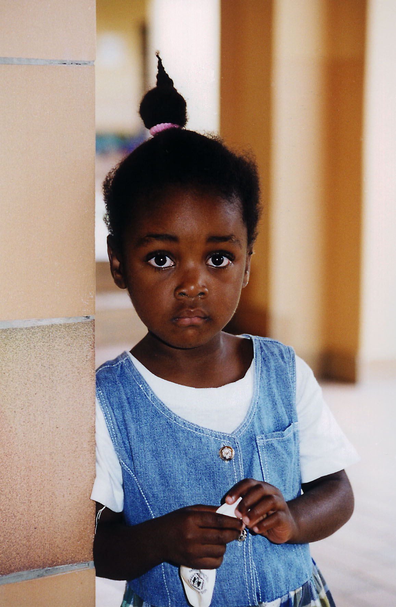
- Have a better-paid job, and therefore a better standard of living
- Be empowered and be able to demand their rights
- Be healthier as they will have been educated about sanitation and diseases such as HIV/AIDS, and they will be able to afford treatment
- Be independent and self-sufficient: they will not have to rely on others for money or food. This improves a person’s confidence and self-esteem
- Improve the health of their own families when the children become parents themselves. This is particularly true when educating girls. In developing countries, childcare falls much more to the mother. If a mother knows about hygiene, sanitation and the signs of illness, she can help prevent infant mortality. An educated woman is also more likely to be independent, be more equal in a relationship, and demand the use of contraception, which decreases the number of pregnancies she has and means she is less likely to die from pregnancy
- Help towards the economic growth of the country.
Child in SOS Children’s Village, Lubango

Education is the most cost-effective and sustainable way of ensuring economic and social development today: according to the United Nations Educational, Scientific and Cultural Organisation (UNESCO),

“Education … constitutes a vital tool for addressing virtually all global problems relevant for sustainable development, in particular poverty, HIV/AIDS, environmental degradation, knowledge formation and sharing, rural development and changes in production and consumption patterns.”
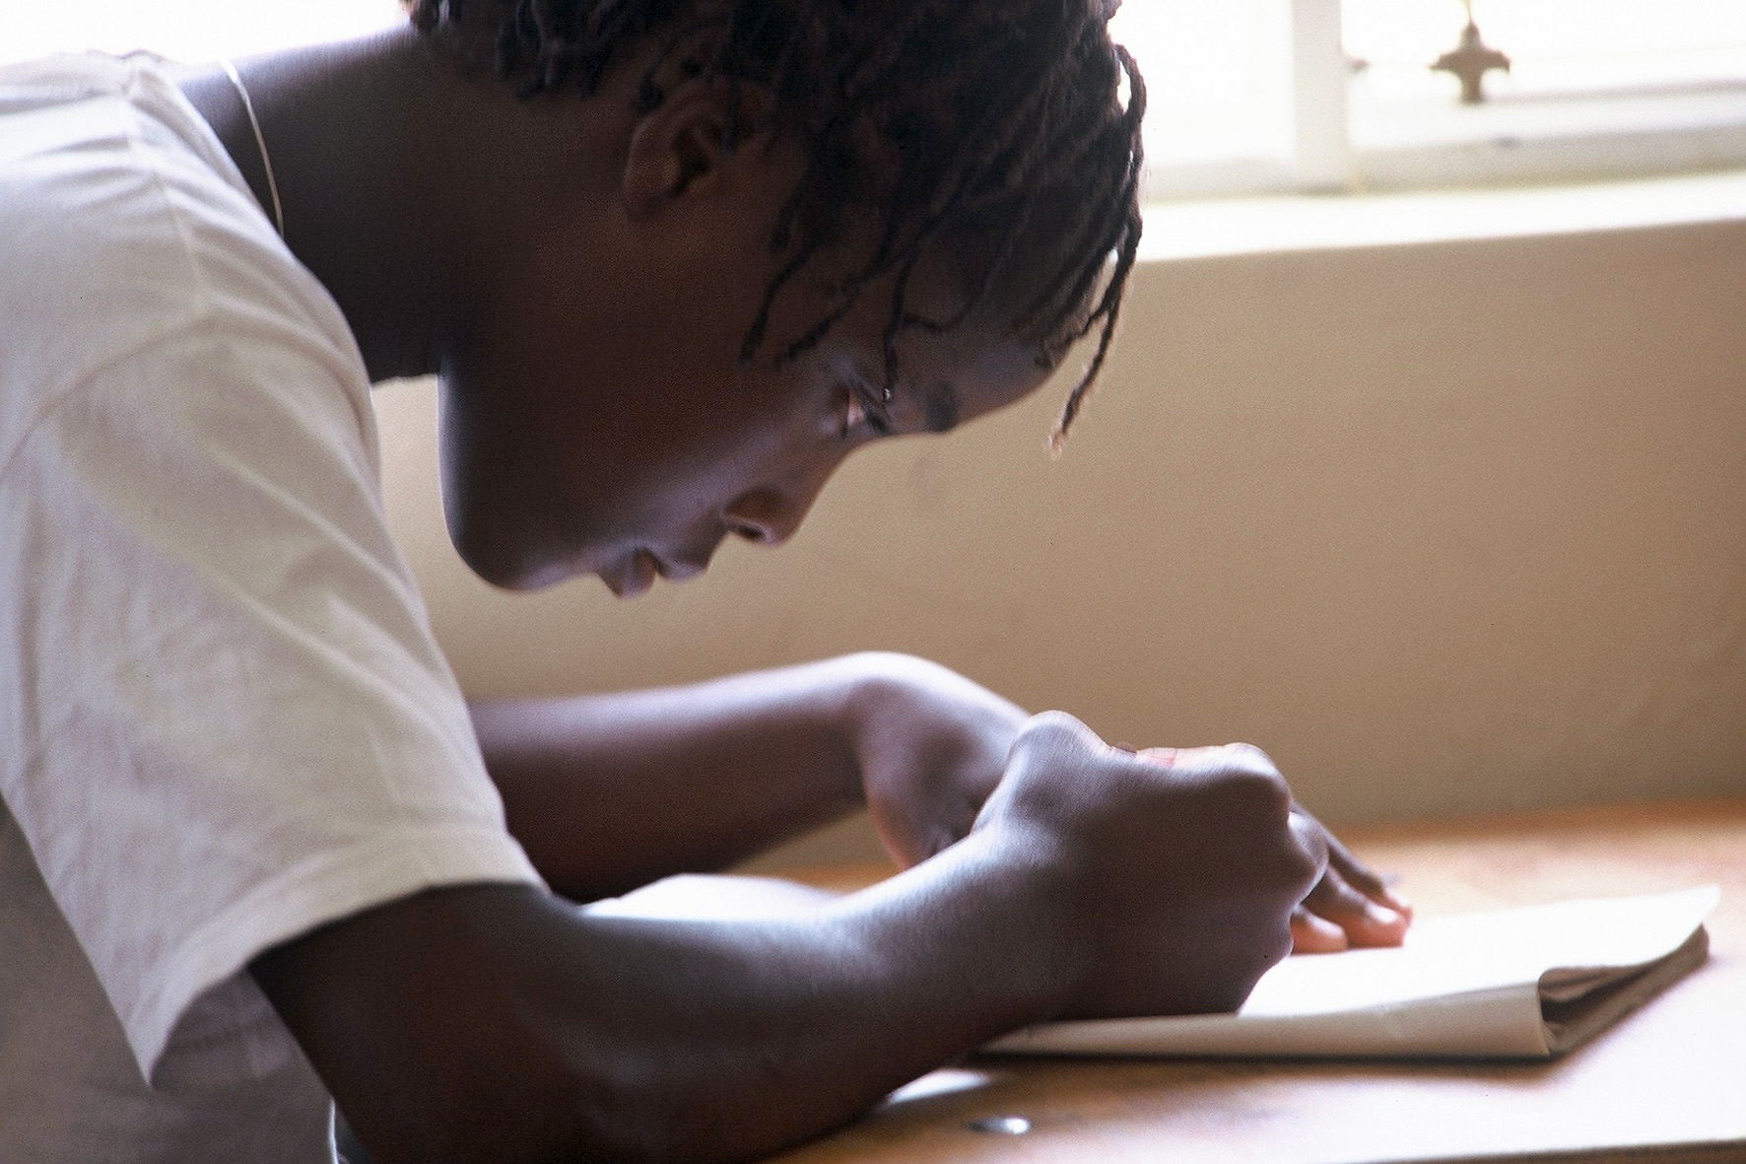
SOS Children is known not only for its Children’s Villages, but also for its commitment to education.

We build and run schools as well as running Vocational Training Centres for youths, which provide them with the skills needed by local labour markets. SOS Children does not want children to be dependent on hand-outs when they are older: we want our children to have the skills they need to shape their own futures. SOS Children’s schools offer scholarships to the poorest students, and we provide all uniforms, stationery and other necessities. We believe in equality of opportunity. Our schools have given poorer communities, such as the communities in Angola that will receive the footballs, a lifeline.

SOS Primary and Secondary Schools, Angola
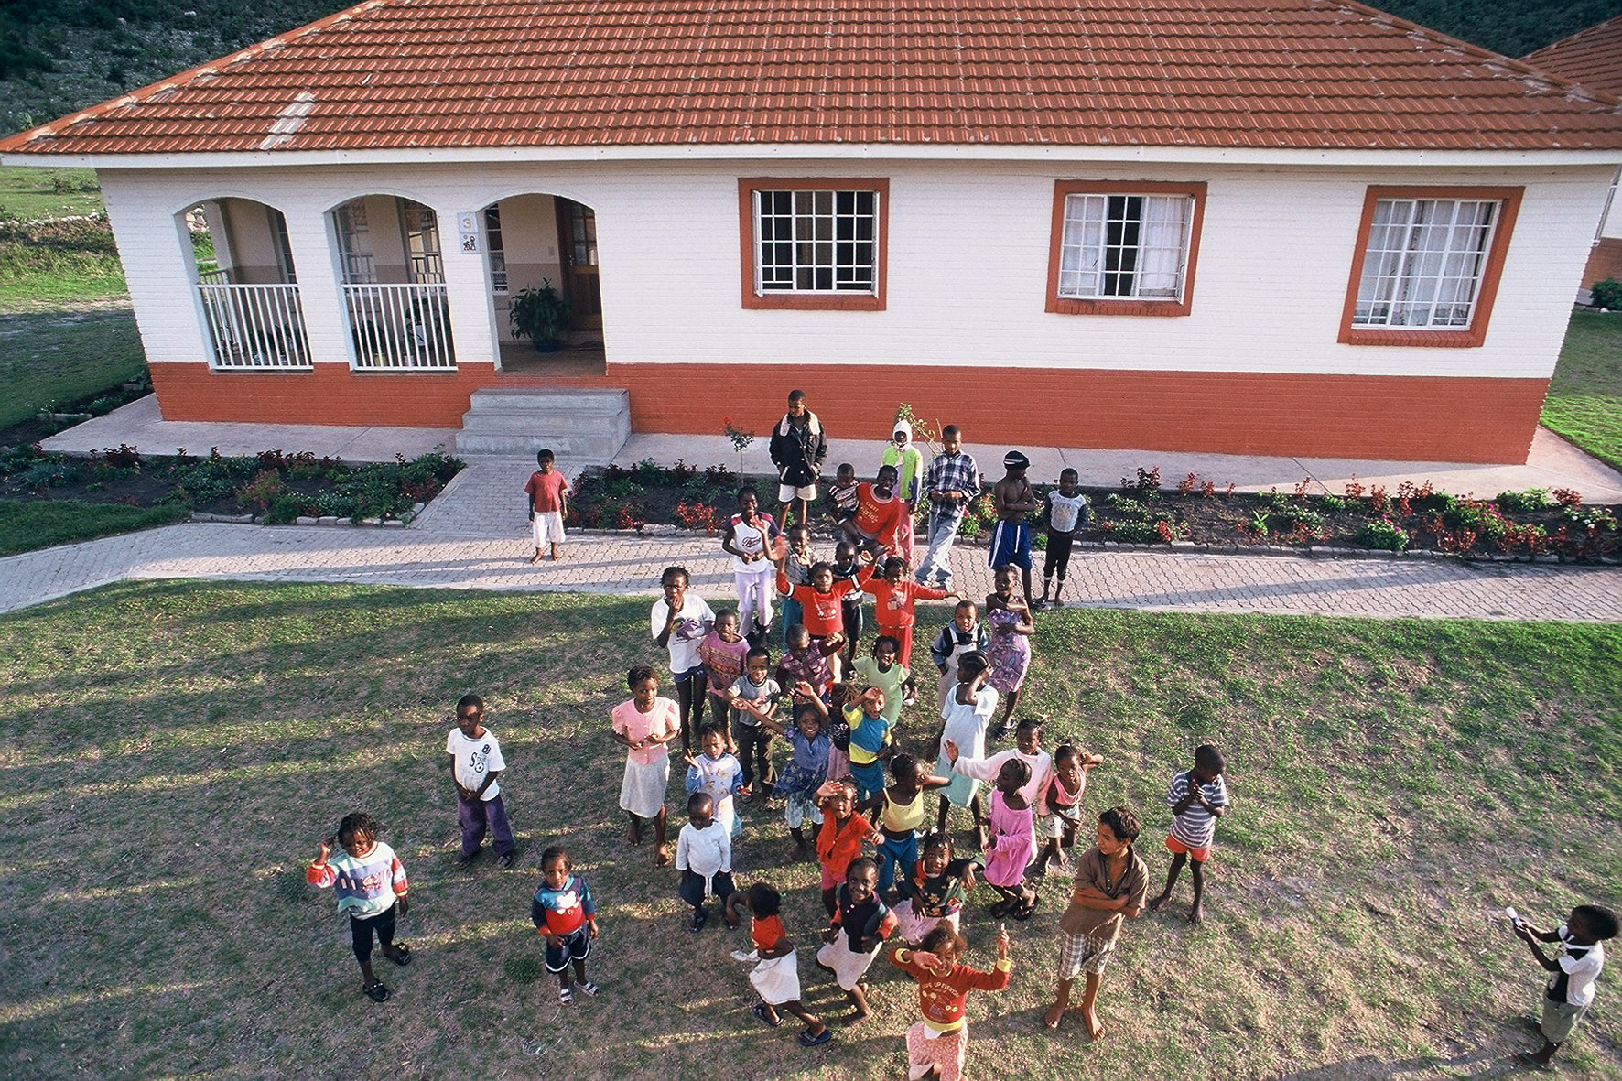
Children from Benguela and Lubango, Angola have really benefited from the SOS primary and secondary schools in their towns. The schools have made a very positive impact and have really increased the education levels of the local population.

SOS Children’s Village Lubango has 12 family houses, which are home to 120 children. The village also has a nursery, a primary school, a clinic and a small farm. Like all SOS Children's Villages, the nursery, school and clinic are open to local people. With many state-run schools and hospitals closed because of the political situation, these projects provide care for the wider community that otherwise is not available.
Children at the SOS Children’s Village in Lubango

SOS Children's Village Benguela has a nursery, primary school and medical centre. There are 12 family homes for 120 orphaned and abandoned children, many of them war orphans. The primary school has nearly 500 children in 12 classes.

Students at the SOS secondary schools have lessons in Science, Maths, Social Science, Business Studies and Language. Technical courses on offer include Food and Nutrition, Arts and Crafts, Woodwork, Metalwork and Mechanics. SOS Children takes care to select courses at its technical and vocational training centres which provide young people with the skills needed by the local market. This means students are more likely to secure employment when they graduate as their skills will be in demand. Having more skills workers and jobs means the local economy will grow, benefiting the entire community.

