The Adventures
of
Little Honey Bunny

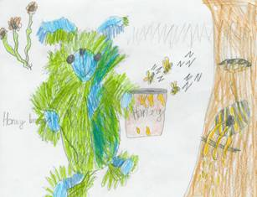

The Adventures of Little Honey Bunny

Once upon a time in the land of Honey Bunnies there was a great discovery. The chief Honey Bunny found an old, ancient map in a treasure chest.

All the Honey Bunnies met in the old church hall to inspect the ancient map. The chief pointed to a large cross showing exactly where the treasure was hidden – it was just inside the orchard.

Everybody gasped in amazement.
‘Wow! Let’s all go and find the treasure!’

Off to the orchard they all marched carrying spades. Even the little bunnies carried shovels and trowels, so they too could help in the excavation of the …..?
But nobody knew what they would find!
1

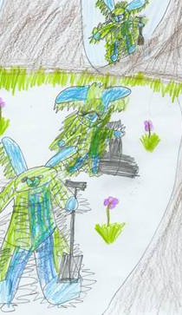

2

Right on the spot where the cross was on the map, stood a very large, old apple tree.

‘Phew! It must be at least one hundred years old!’ said Little Honey Bunny.

At the back of the tree they discovered a large hole, which went down and down into the ground.

The chief tried to go down the hole to find the treasure, but he was too big.

Guess who was just the right size to go down the hole? That’s right! Little Honey Bunny!
They all shouted ‘Hurray!’ as Little Honey Bunny scampered down the hole in the old, old tree.

And that was the beginning of an amazing adventure.
3

Down and down, deeper and deeper crawled Little Honey Bunny, to the very centre of the Earth, or so it seemed to him.

When he turned the last bend he was shocked and frightened, as two bright eyes shone in the dark.

‘Hello’ said the creature.
‘Er, hello’ whispered Little Honey Bunny. ‘Who are you?’

The creature smiled and said, ‘I am the keeper of the mysterious treasure.’
‘Do you think I could have a look at the treasure, please?’
‘Only if you say the magic words!’ said the creature.
‘But I don’t know the magic words.’
‘Well’ said the creature, ‘I’ll give you a clue then’ …
4

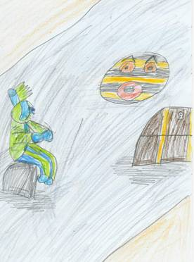

5
The creature then gave him a puzzle,
‘YY UR, YY UB, I C U R … A Y’s B?’

‘I think the answer is A Wise Bee!’ shouted Little Honey Bunny.

‘That’s right. Well done. You are obviously a very clever little bunny! Now I will show you what’s in the treasure chest.’ With that he slowly opened the lid of treasure chest.

Little Honey Bunny peered inside excitedly, looking for gold. But he was disappointed to find out that all there was in the chest was a little red seed.

‘That’s not treasure! That’s just a seed!’

The guardian of the treasure said, ‘Now listen, my little friend. When you plant this special seed, you will be
6
surprised to find it will grow into a beautiful Honey Plant, which will give
you the sweetest, tastiest honey you have ever seen!’

With that Little Honey Bunny thanked the guardian of the treasure, and climbed slowly back up the tunnel to the surface.

As his head popped out of the entrance to the hole everybody cheered.

‘Hooray! He’s back. He’s got the treasure chest!’

When he opened the chest everyone crowded around. But when they saw that it only contained a little red seed they sighed in disappointment.

‘That’s not treasure!’ they complained.

7

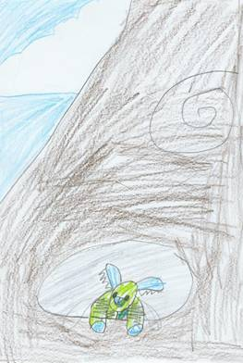

8
Little Honey Bunny picked up the seed and planted it in the soil, at the side of the large apple tree.

Much to everyone’s surprise, the seed grew and grew, and within just two weeks a beautiful Honey Plant stood in the orchard.

When the spring came, the plant was covered in lovely pink blossom, which after a while turned into tiny pots of tasty, sweet, golden honey. Bunnies came from far around to admire this wonderful tree.

Little Honey Bunny was allowed to pick the first pot from this magic tree.
‘I know’ he said, ‘I’m going to give this pot to the guardian of the treasure chest.’ And off he hopped down the hole.
9

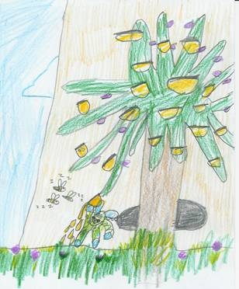

10
The guardian was delighted to receive the honey and thanked Little Honey Bunny very much.

‘Each spring I will bring you the first pot of honey’ said Little Honey Bunny ‘as a thank you for your kindness.’

And do you know, each year he did!

THE END

11


The author of this book is Jordan Aspinall who is age 7 (as at March 2006), and lives on the Isle of Wight.

Jordan is a keen writer and enjoys drawing pictures.

His Granddad has helped him put the story ideas together for this book.

The inspiration for the story came from a soft toy he bought, which he named Honey Bunny.

Jordan has produced this book to raise money for SOS Children, the world’s largest orphan charity.
Registered charity number: 1069204

12

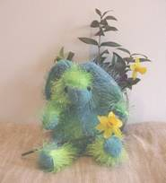

Thank you for buying this book.
Proceeds are going to
SOS Children
Registered charity number: 1069204

£1

